Exhibit C
Fixed Specifications

In addition to the contract guarantee points, the following specifications can be considered fixed with respect to this purchase order.

C.1 Exhaust Stack Height:
Each Unit contains an exhaust stack which discharges the powerplant exhaust gas. The height of this stack will be determined by local regulations and dispersion analyses. This stack may be any height up to 40 feet without impacting the price of the purchase order

C.2 Hazardous Materials
Anticipated hazardous materials inventory at the site is as follows:
Table C.1 Anticipated hazardous materials inventory
 | Normal | Maximum
 | Amount | Amount
Chemical | On Site | On Site
Preconverter Catalyst - 20-30% Ni, 30-35% NiO, balance ceramic substrate | 250 lbs | 500 lbs
Sulfur Sorbent - Activated Carbon, may contain up to 25% CuO or KOH | 4000 lbs | 8000 lbs
Lubricating Oils | 5 gallons | 10 gallons
Misc. Cleaning Chemicals | 5 gallons | 10 gallons

C.3 Type and location of required gas and liquid connections to unit at site
See drawing, “Purchaser/Seller Interconnection Summary”.

C.4 Basis Conditions and Performance Correction Factors
The basis conditions, which the powerplant price and performance guarantees are based upon, are as follows:

General Site Conditions
- The site is clear and level, free of hazardous materials, and graded to ensure drainage of surface water.
- The site soils are capable of a bearing pressure of 4000 pounds/square foot (PSF).
- All-weather road access at the front of the site is available. The road will have sufficient load bearing capacity for the heaviest single equipment skid (120,000 lb), plus its transport and/or crane.

Specific Site Conditions are as shown in the following table:
Table C.2 Site Basis Conditions
CATEGORY | DESIGN CONDITIONS | PERFORMANCE POINT⁽²⁾
Elevation above Sea Level | 0 to 2500 ft | 0 ft
Ambient Temperature | -20 to 104 F | 59 F
Relative Humidity | 0 to 100 % | 60 %
Wind Loading @ 33 ft | 24 PSF ⁽³⁾
Snow Load | 30 PSF ⁽⁴⁾
Precipitation | 2.5 inches/hour
Seismic | UBC Zone 2
Ambient Dust Loading, Ave./yr | 27 micro-gram/m³
Ambient Gaseous Halide Concentration, Ave./yr | 20 ppbw
Ambient Gaseous Sulfur Dioxide Concentration in Air | < 10 ppb
Notes:
(1) Highway access is required. Rail siding is not required.
(2) Basis for powerplant performance calculations.
(3) This wind load of 30 PSF is based on a wind speed of less than 90 mph and Exposure C. Exposure C is defined as “Open terrain with scattered obstructions having height generally less than 30 feet” (American Society of Civil Engineers standard ASCE 7-95).
(4) This snow load is equivalent to a ground snow load of 40 PSF and a snow exposure factor of 0.7 per Uniform Building Code UBC-97.

Fuel Composition
Basis fuel composition range used for performance estimation is as follows:
Table C.3 Fuel Composition Range
PROPERTY | RANGE
Composition  Methane, vol %  Ethane, vol %  Propane vol %  Butanes, vol %  Pentanes+, vol %  Unsaturated Hydrocarbons  Inert Gases  - Nitrogen, vol %  - Carbon Dioxide, vol %  Oxygen, vol % | 80 - 100  0 - 10  0 - 3  0 – 1.25  0 - 0.5  None  0 - 5  0 - 3  0 – 3  0
Impurities  Total Sulfur, ppmv  grains/100 SCF  - H2S, ppmv  - COS, ppmv  - Odorants, ppmv  Halogens (Cl, etc)  Dust/Gum/Solid Matter  Water, lb/MMscf | 0 - 12  0 - 0.7  0 - 0.8  0 - 2  0 - 12  None  None  0 - 7
C.5 Correction Factors
The impact of ambient conditions on the performance of Direct FuelCell powerplants is much less severe than that seen with heat engines, but there are some impacts. The following sections discuss the impact of various site conditions on performance, and the correction factors which can be used to adjust measured performance to performance expected under standard condition.

C.5.1) Ambient Temperature
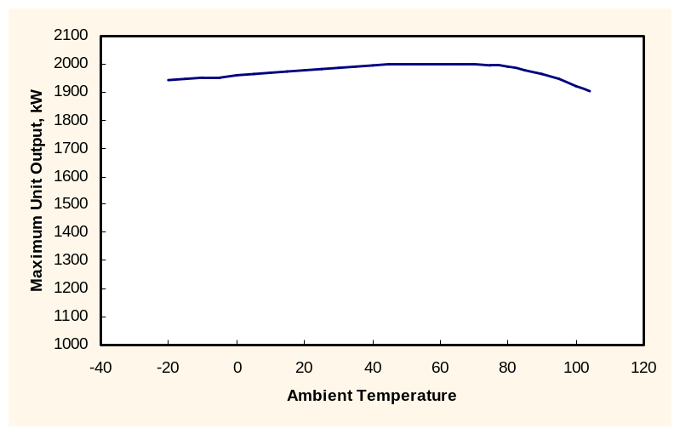
Ambient temperature affects the fuel cell performance by impacting the amount of air needed by the powerplant. The impacts are as shown in Figures 1 and 2, which shows the trends for a 2MW unit. The specific impacts are discussed in Table 1, which also gives correction factors.
Figure C.1
Effect of Ambient Temperature on Power Output (2MW Unit)

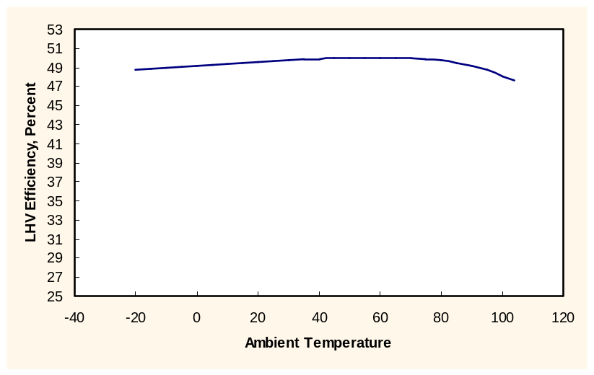

Figure C.2
Effect of Ambient Temperature on Efficiency (2MW Unit)

Table C.4
Summary of Temperature Impacts and Corrections
Temperature Range | Impact | Correction
Baseline Temperature, 59ºF  and Baseline Range of  40ºF to 80ºF | No Impact | No Correction
High Range  81ºF to 104ºF | Additional air needed to maintain system thermal balance: higher air blower power, dilution of cathode CO₂. Results in 5% power loss and 2.4 percentage points LHV efficiency drop at 104ºF | For T_{amb}>80ºF  Maximum Unit Output =  Measured Output * α_{T}, where  α_{T}= ( 0.842+.002*T_{amb} ), where T_{amb} is local ambient temperature, degrees Fahrenheit  Efficiency (as percent, LHV)=  Measured Efficiency + ω_{T}, where  ω_{T} = (T_{amb} *0.1-8)
Low Range  -20ºF to 39ºF | Less air is needed to maintain system thermal balance: lower air blower power, but dilution of cathode O₂ reduces cell performance. Results in 3% power loss and 1.2 percentage point LHV efficiency drop at  –20ºF | For T_{amb}<40ºF  Maximum Unit Output =  Measured Output x α_{T}, where  α_{T}= ( 1.02-.0005*T_{amb} ), where T_{amb} is local ambient temperature, degrees Fahrenheit  Efficiency (as percent, LHV)=  Measured Efficiency + ω_{T}, where  ω_{T} = (0.8-T_{amb} *0.02)

C.5.2) Elevation
The effect on the powerplant due to operation at elevations above sea level (due to the lower barometric pressure) stems from two impacts: At lower barometric pressure, the air supply blower has to deliver more volume to provide the required mass flow for thermal balance. This will result in an additional parasitic loss on the order of 15kW for the 2MW plant and 18kW for the 2.4MW plant (~0.75%) at 2500 feet above sea level (i.e. at an ambient pressure of 13.4 psia vs 14.7psia at sea level). Also, the fuel cell reactions are slightly less efficient at lower pressure, bring the impact on power up to 1.5% . The performance correction is therefore:

Maximum Unit Output = Measured Unit Output x α_{H} where
α_{H} = 1+H x 0.006,
Where H = elevation, thousands of feet above sea level. In terms of barometric pressure, the relationship is:

Maximum Unit Output = Measured Unit Output x α_{H} where
α_{P} = 1.17 - P x 0.0015
Where P = Pressure, psia

Efficiency is impacted by 0.8 percentage points. The correction is
Efficiency (as percent, LHV) = Measured Efficiency + ω_{H} , where
ω_{H} = 0.32 x H,
Where H = elevation, thousands of feet above sea level.
So 49.2 percent LHV efficiency measured at 2500 feet above sea level would be corrected to 50 percent, by adding 0.32 times 2.5.

In terms of pressure, the correction is:
Efficiency (as percent, LHV) = Measured Efficiency + ω_{P} , where
ω_{P} = 9.04 - 0.615 x P,
Where P = barometric pressure, psia
For example, if ambient pressure is 13.4 psi (e.g. @ 2500 feet), then
ω_{P} = 9.04 - 0.615 x 13.4 = 0.8 percentage points
An efficiency of 49.2 percent measured with 13.4psi ambient pressure would be corrected to 49.2 + ω_{P}, or 49.2 + 0.8 = 50 percent

C.5.3) Natural Gas Composition.
So long as the natural gas composition falls within the range listed in Table C.3, no adjustment need be made to the efficiency or power output. This range covers a large percentage of North American natural gas pipeline supplies. For natural gas compositions outside this range, the specific gas composition will need to be analyzed to determine the performance impact.

C.5.4) Power Factor
The plant will be designed to provide Maximum Unit Output with a power factor range of 0.9 leading to 0.9 lagging. Incorporating electrical equipment in anticipation of restacks with higher output capability within the same power factor range extends this capability. This results in an anticipated output capability of 3000kW with 0.9 leading or lagging power factor, or 3333 net KVA. For 2 and 2.4MW powerplants operating with a wider power factor range, power output will not have to curtailed unless total KVA exceeds 3300. For the 2MW plant this is 0.6 power factor, for the 2.4MW plant this is .73 power factor. Power factors outside this range will require a reduction in power output to keep total KVA below 3300.

C.5.5) Operating History
The power output and efficiency projections for stack modules operated for extended periods of time assume that no more than two thermal cycles per calendar year occur. A thermal cycle is defined as a cooldown of the stack to less than 900 degrees Fahrenheit. If the stack modules are cycled more than twice per year, an additional performance loss may occur.

For every extra annual thermal cycle (beyond 2 per year), Maximum Unit Output should be corrected by 1%, i.e.

Maximum Unit Output = Measured Output x (1+n/100), where
n = number of thermal cycles per year in excess of two.

Efficiency is only impacted by about 0.3 percentage points, so the correction is:
Efficiency (as percent LHV) = Measured Efficiency + 0.3n, where
n = number of thermal cycles per year in excess of two.

Beyond thermal cycles, operating plant subsystems outside of their temperature or pressure limits may also impact plant performance in unpredictable ways. These limits will be specified in the operating manuals for the powerplants.

C.5.6) Relative Humidity
The effect of humidity on the powerplant performance is very small, so no correction need be used.

